AWS ADVANCE PROJECT 5-LU:
PROJECT : SCHEDULING A BASIC JOB IN JENKINS:
Task1: Create a free style project.
Procedure to create.
Create a Repository on github and a file in it.
Log on to Jenkins dashboard.
Click on new item, free style project, the click ok.
● Screenshot of Jenkins home page with job list
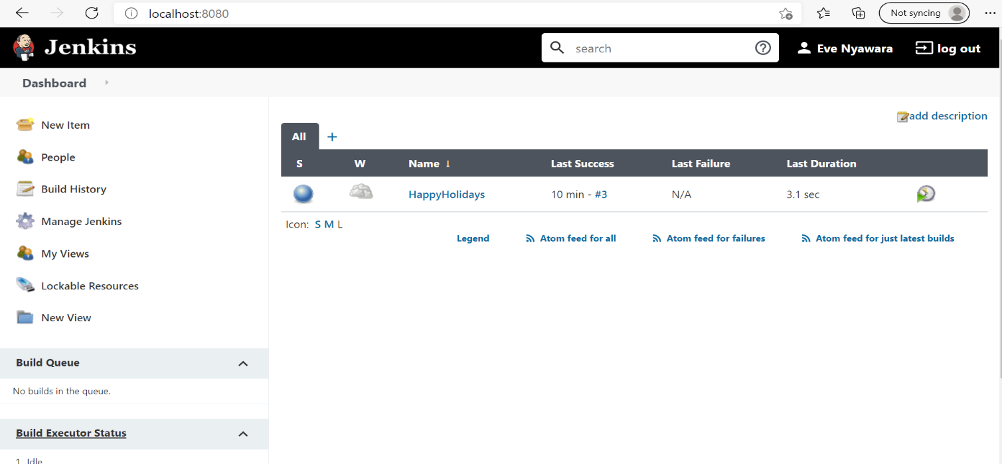
Task2: Configure git SCM
● Screenshot for git Source Code Management config tab;
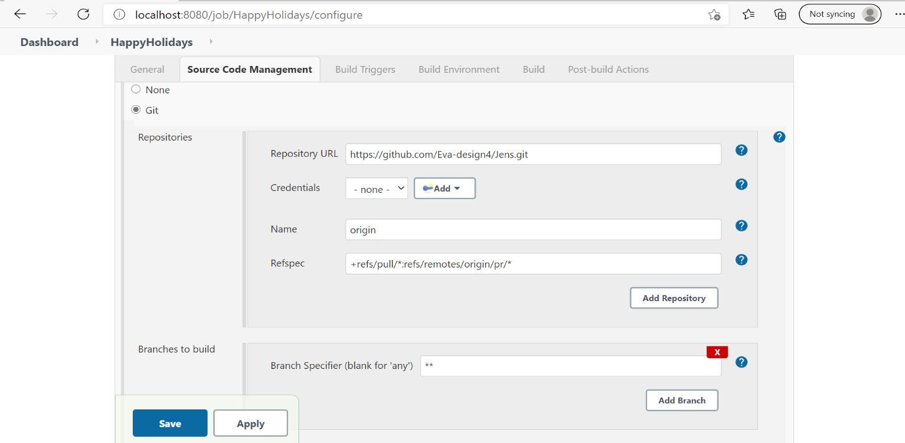

Task3: Add build step-java commands in execute windows batch commands
● Ss:commands
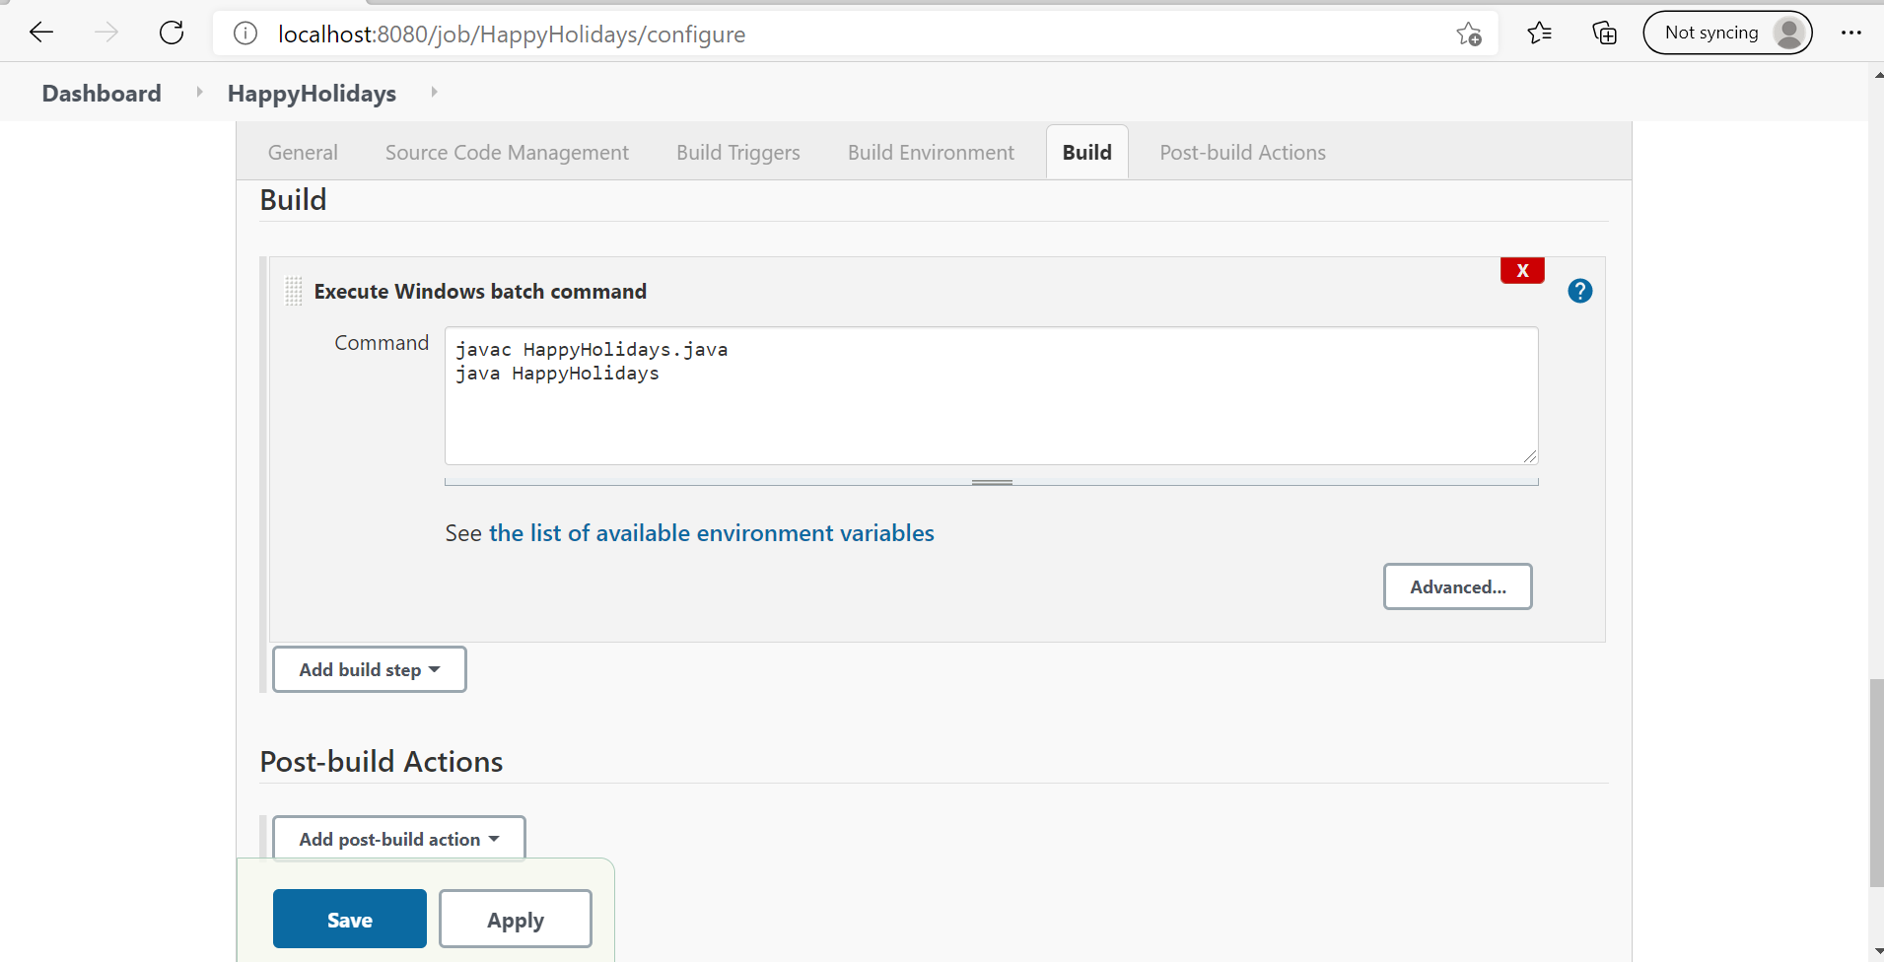
Task4: Run a build and show console output
● Screenshot ; console output-build success
